1. Navigating Labview.
LabVIEW. Labview is a graphical programming environment you can used to develop sophisticated measurement, test, and control systems.

PROJECT EXPLORER. Projects in LabVIEW consist of VIs, files necessary for those VIs to run properly, and supplemental files such as documentation or related links. Use the Project Explorer window to manage projects in LabVIEW. The Project Explorer window includes the following items by default:
- Project root: Contains all other items in the Project Explorer window. The label on the project root includes the filename for the project.
- My Computer: Represents the local computer as a target in the project.
- Dependencies: Includes VIs and items that VIs under a target require.
- Build Specifications: Includes build configurations for source distributions and other types of builds available in LabVIEW toolkits and modules.

FOLDERS IN PROJECT EXPLORER. There are two types of folders in the project Auto-populated folders and Virtual folders.
- Auto-populated folders: adds a directory on disk to the project.
- Virtual Folder: organizes project iteems and doesn't represent files on disk.

LABVIEW FILES. The common labview exteensionns files are Labview Project (.lvproj), Virtual Intstrument (.vi) and Custom Control (.ctl).

PARTS OF A VI. Labview VIs contain three main components front panel, block diagram and the icon/conector pane.
- Front panel: User interface for the VI. Contains controls and indicators, which are the interactive input and output terminals of the VI, respectively. LabVIEW has different control palettes with objects for building user interfaces. These palettes include the Modern, Silver, Classic, and Systems palettes.
- Block diagram: Block diagram objects include terminals, subVIs, functions, constants, structures, and wires, which transfer data among other block diagram objects. The components of a block diagram are: terminals, nodes, functions nodes, SubVIs, icon, connector pane.
- Icon/conector pane: Icons are the graphical representation of VIs and the connector pane is the map of inputs and outputs of a VI.

EXPRESS VIs. Express VIs are a type of subVI that you configure with dialog boxes. Icons for Express Vis appear on the block diagram as icons surrounded by a blue field.

WIRES. Wires transfer data between block diagram objects. A broken wire appears as a dashed black line with a red X in the middle. You cannot run a VI that contains a broken wire. Common wire types: scalar, 1D Array and 2D Array.

CONTEXT HELP. The Context Help window displays basic information about LabVIEW objects when you move the cursor over each object.

CONTROLS PALETTE. The Controls palette contains the controls and indicators you use to create the front panel.

FUNCTION PALETTE. The Functions palette contains the VIs, functions and constants you use to create the block diagram.

QUICK DROP. The Quick Drop dialog box lets you quickly find controls, functions, VIs, and other items by name.

2. Creating your fist application.
DATAFLOW. Dataflow is the movement of data through the nodes of a block diagram.

LABVIEW DATA TYPES. Block diagram terminals visually communicate information about the data type represented.
Terminal colors, text, arrow direction, and border thickness all provide visual information about the terminal.
- Boolean Data: Boolean controls and indicators to enter and display Boolean (TRUE/FALSE) values. LabVIEW stores Boolean data as 8-bit values. If the 8-bit value is zero, the Boolean value is FALSE. Any nonzero value represents TRUE.
- NUMERIC DATA: LabVIEW represents numeric data types as floating-point numbers, fixed-point numbers, integers, unsigned integers, and complex numbers. The difference among the numeric data types is the number of bits they use to store data and the data values they represent.
- STRINGS: A string is a sequence of displayable or non-displayable ASCII characters. Strings provide a platform-independent format for information and data.
- ENUMS: Enums give users a list of items from which to select. Enums are useful because they make strings equivalent to numbers, which are easy to manipulate on the block diagram. Each item represents a pair of values: a string value and a 16-bit integer.
- DYNAMIC: Stores the information generated or acquired by an Express VI.
- PATH: Stores the location of a file or directory using the standard syntax for the platform you are using.
- WAVEFORM: Carries the data, start time, and dt of a waveform.
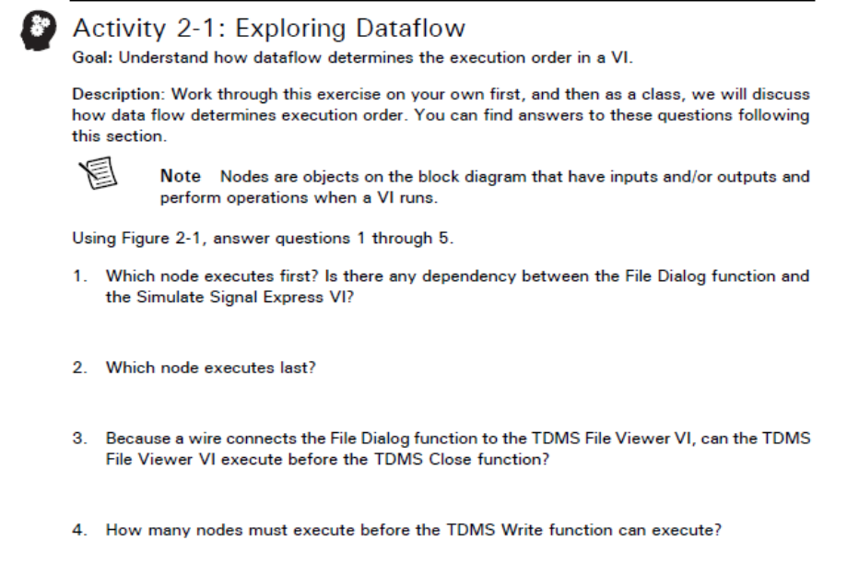
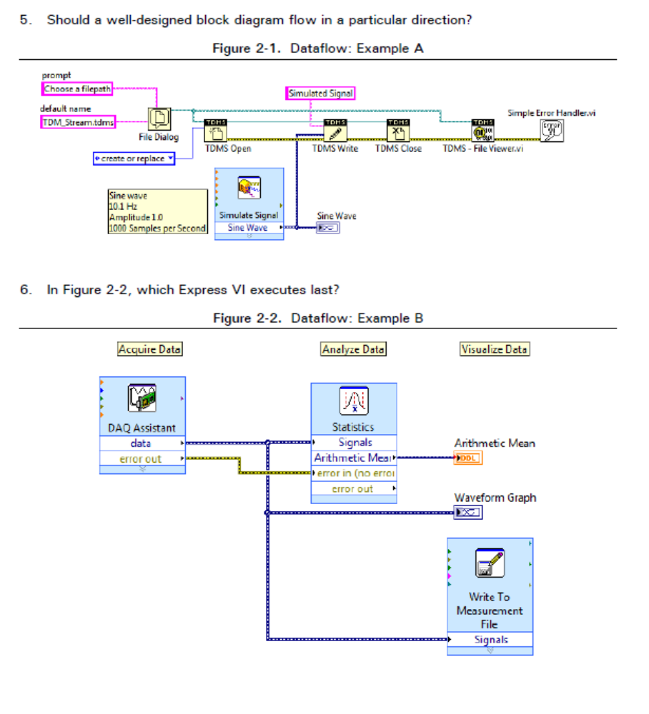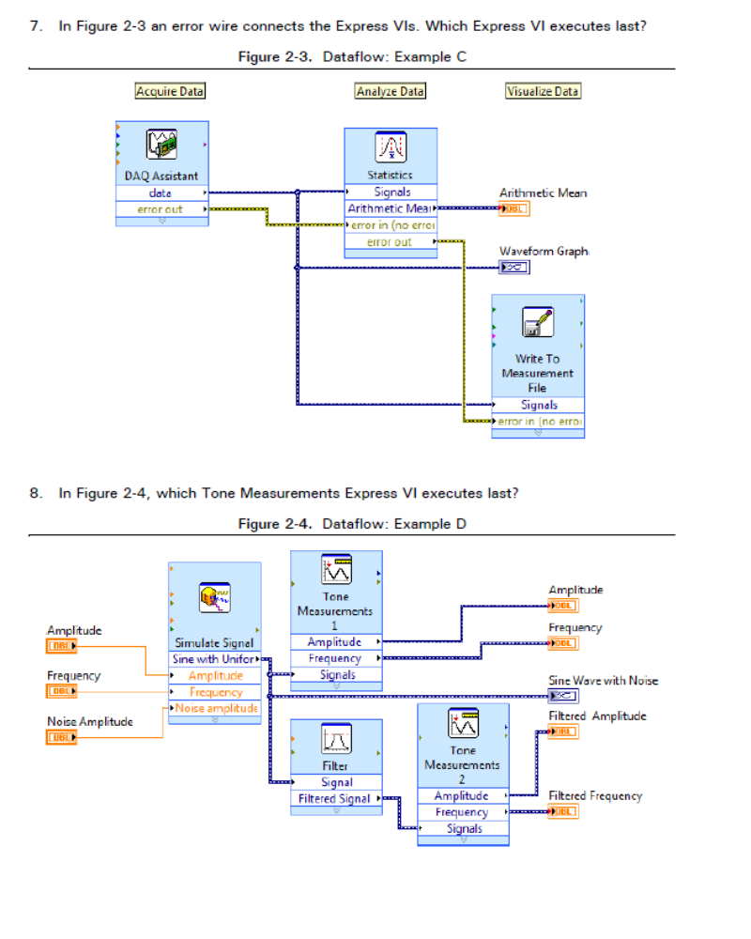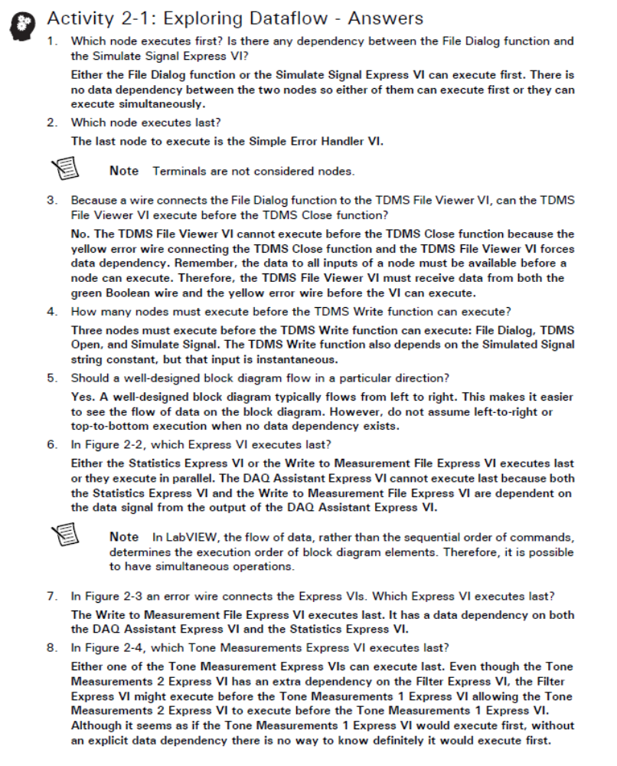
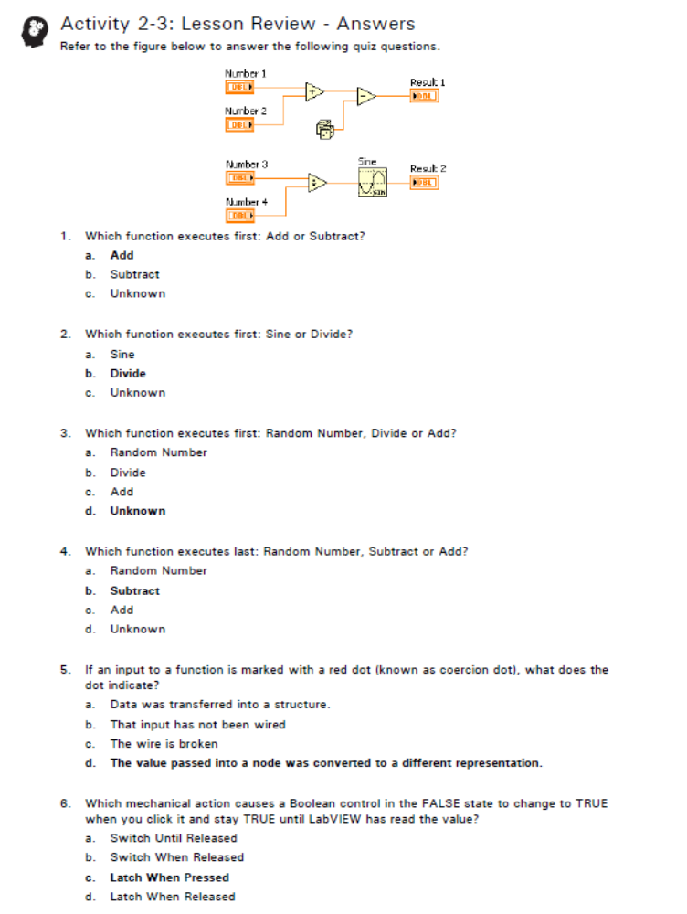

3. TROUBLESHOOTING AND DEBUGGING VIs

Breakpoints. Use the Breakpoint tool to place a breakpoint on a VI, node, or wire and pause execution at that location.

Retain wire values. Retain Wire Values enables you to probe wire values after execution completes. This option uses more memory because LabVIEW is storing data for each wire as it runs.

Undefined or unexpected data. Floating-point operations return the following two symbolic values that indicate faulty computations or meaningless results.

Error handling. Anticipation, detection, and resolution of warnings and errors.

Automatic error handling. At run time, LabVIEW suspends execution, highlights node where error
occurred, and displays Error dialog box.

Manual error handling. You control when dialog boxes appear, propagate errors through error in/error out clusters, terminate error chain with Simple Error Handler.

Error clusters. VIs and functions return errors in one of two ways—with numeric error codes or with an error cluster. Typically, functions use numeric error codes, and VIs use an error cluster, usually with error inputs and outputs. Use the error cluster controls and indicators to create error inputs and outputs in subVIs. The components of an error cluster are:
- status: a Boolean value that reports TRUE if an error occurs
- code: a 32-bit signed integer that identifies the error numerically. A non-zero error code is coupled with a status of FALSE signals a warning rather than an error
- source: a string that identifies where the error occurred

Differences betwen errors and warnings.
- Errors: Status = True, Code = Non-zero, more severe and passed to the next node without executing that part of the code.
- Warnings: Status = False, Code = Non-zero, less severe and node executes normally, but it is important to monitor warnings during development to ensure proper behavior of your application.

Merge Errors. The Merge Errors Function Returns the first error found. If no error is found, it returns the first warning and does not concatenate errors. Use Merge Errors to propagate errors along wires and merge errors from different wire paths.

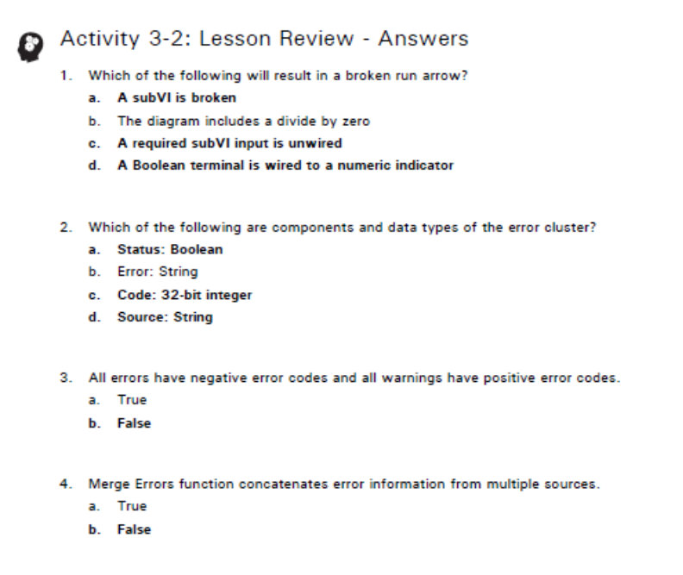

Using Loops.
While Loops. Similar to Do Loop or a Repeat-Until Loop
- Repeats code segment until a condition is met
- Always execute at least once
- Iteration terminal—output that contains the number of complete iterations
- Iteration terminal always starts at zero
- Conditional terminal sets the condition for stopping the loop

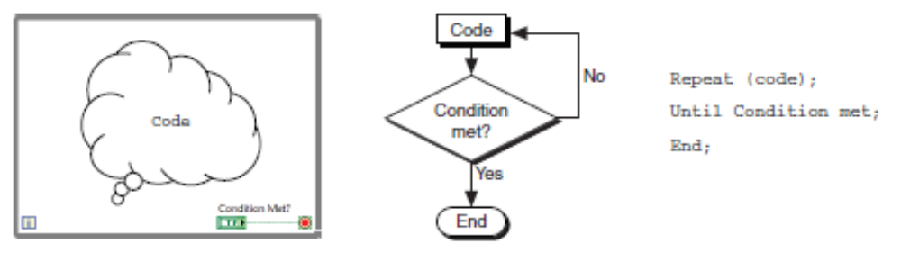

Foor loops. Repeats code a certain number of times
- The value in the count terminal (an input terminal) indicates how many times to repeat the subdiagram in the For Loop.
- Can execute zero times
- Iteration terminal—output that contains the number of complete iterations
- Iteration terminal always starts at zero
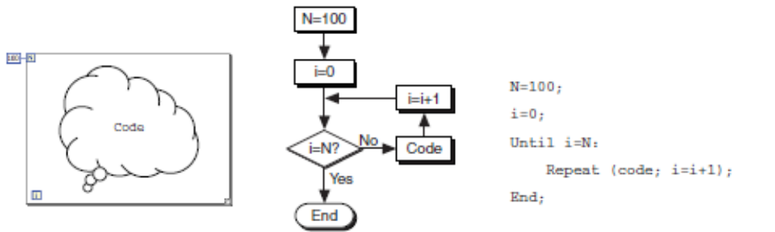
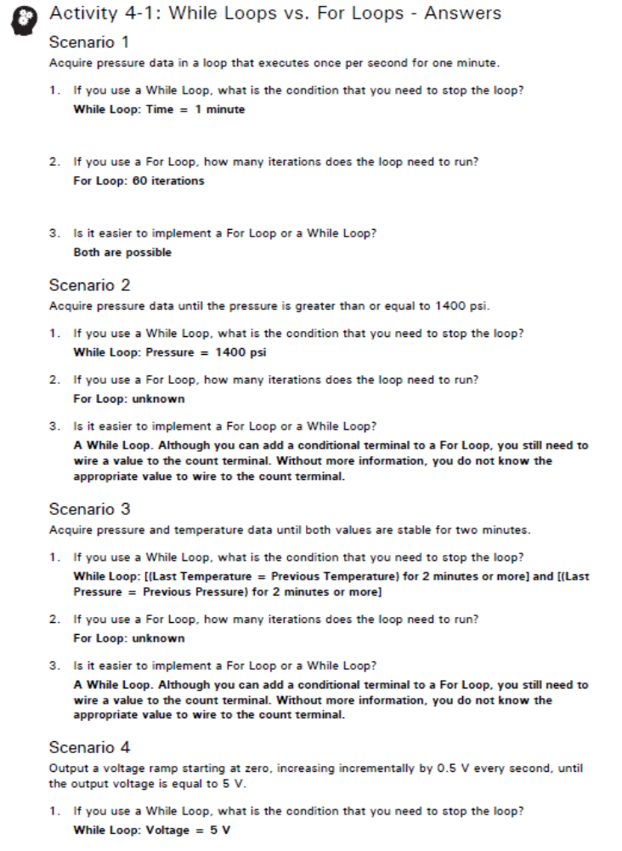
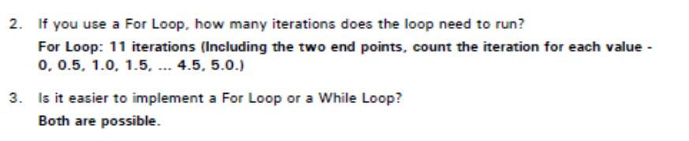
Tunnels. Tunnels transfer data into and out of structures. Data pass out of a loop after the loop terminates.

Condition terminal. a conditional terminal to configure a For Loop to stop when a Boolean condition or an error occurs. A For Loop with a conditional terminal executes until the condition occurs or until all iterations are complete, whichever happens first.

Timing a VI. Use a wait function inside a loop to accomplish the following actions:
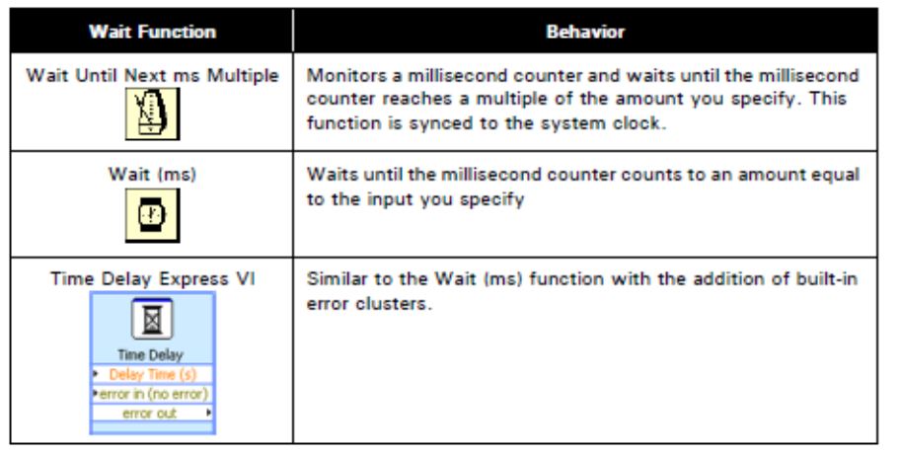
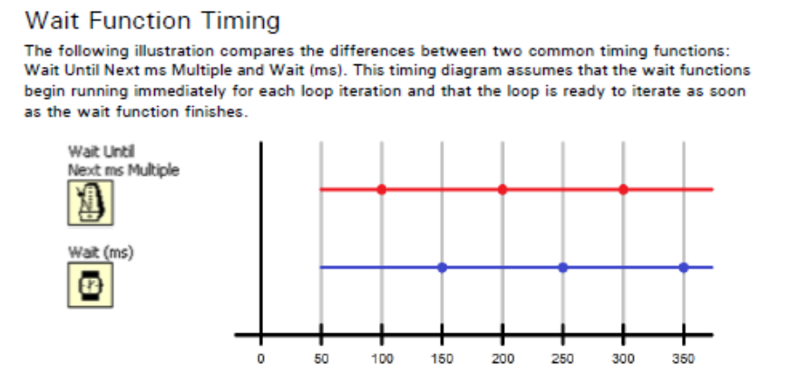
Shift registers. Shift registers store data values from previous iterations of a loop in LabVIEW.

Waveform data. The waveform chart is a special type of numeric indicator that displays one or more plots of data typically acquired at a constant rate. Waveform charts can display single or multiple plots. You can configure how the chart updates to display new data. The chart uses the following modes to display data:
- Strip Chart—Shows running data continuously scrolling from left to right across the chart with old data on the left and new data on the right.
- Scope Chart—Shows one item of data, such as a pulse or wave, scrolling partway across the chart from left to right.
- Sweep Chart—Works similarly to a scope chart except it shows the old data on the right and the new data on the left separated by a vertical line.
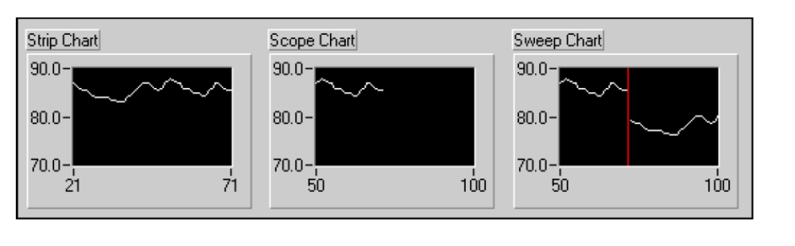
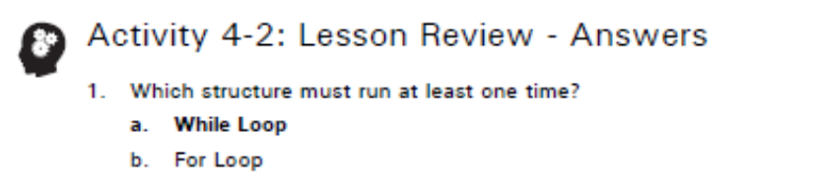

Creating and leveraging data structures.
Arrays. Collection of data elements that are of the same type.

Elements. The data that make up the array. Elements can be numeric, Boolean, path, string, waveform, and cluster data types.

Dimension. Length, height, or depth of the array. Arrays can have one or more dimensions and as many as (231)-1 dimensions.

Arrays restrictions. You cannot create arrays of arrays. However, you can use a multidimensional array or create an array of clusters where each cluster contains one or more arrays. Also, you cannot create an array of subpanel controls, tab controls, .NET controls, ActiveX controls, charts, or multi-plot XY graphs.

Polymorphism. The ability of VIs and functions to automatically adapt to accept input data of different data types. Functions are polymorphic to varying degrees—none, some, or all of their inputs can be polymorphic.

Auto indexing. The ability to automatically process every element in an array.

Waveform graphs. A waveform graph collects the data in an array and then plots the data to the graph.

Waveform charts. Charts are generally used inside the While Loop and graphs are generally outside the While Loop.

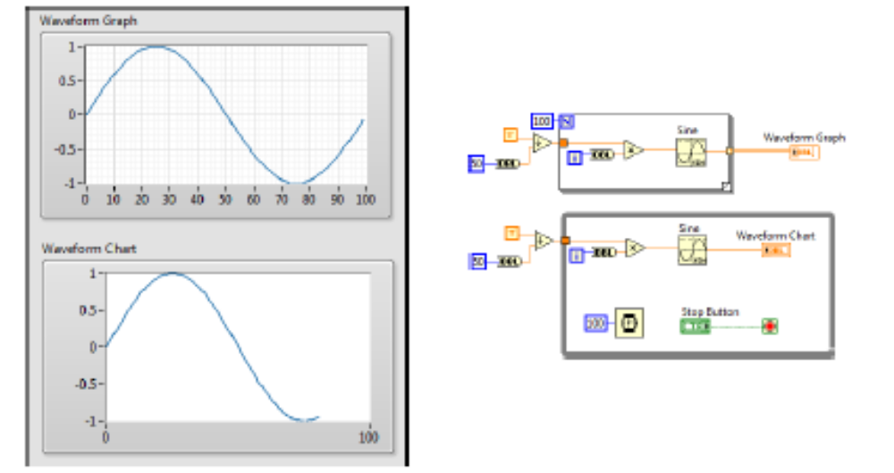

Auto indexing with a conditional tunnel. You can determine what values LabVIEW writes to the loop output tunnel based on a condition you specify.

Auto indexing input. Use an auto-indexing input array to perform calculations on each element in an array. If you wire an array to an auto-indexing tunnel on a For Loop, you do not need to wire the count (N) terminal.

Auto indexing input-different array sizes. If the iteration count terminal is wired and arrays of different sizes are wired to auto-indexed tunnels, the actual number of iterations becomes the smallest of the choices.

Clusters. Clusters group data elements of mixed types controls or indicators it can’t be mixed of control and indicators.

Differences between clusters and arrays.
- Clusters: mixed data types and fixed size.
- Arrays: contain only one data type and vary in size.

XY graph. The Bundle function is often used to create multi-chart plot charts and XY plots. The Build Array function is used to create multi-plot waveform graphs.

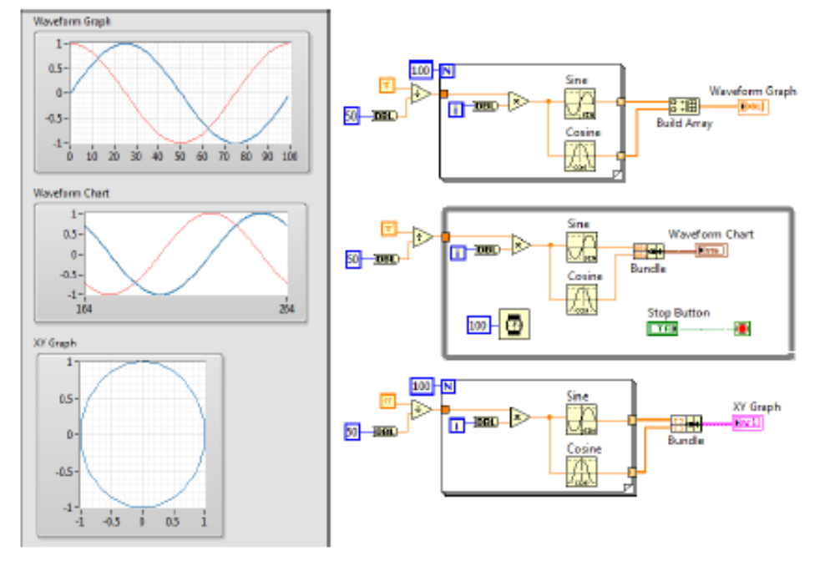
Type definitions. Three types of custom controls—Control, Type Definition, Strict Type Definition.
- Custom controls are templates and used as starting points for other similar controls. Changes made to one control does not reflect in other controls.
- Type definitions and strict type definitions link to all the instances of a custom control or indicator to a saved custom control or indicator file. You can make changes to all instances of the custom control or indicator by editing only the saved custom control or indicator file
- Strict type defs apply cosmetic changes too, whereas type defs do not.
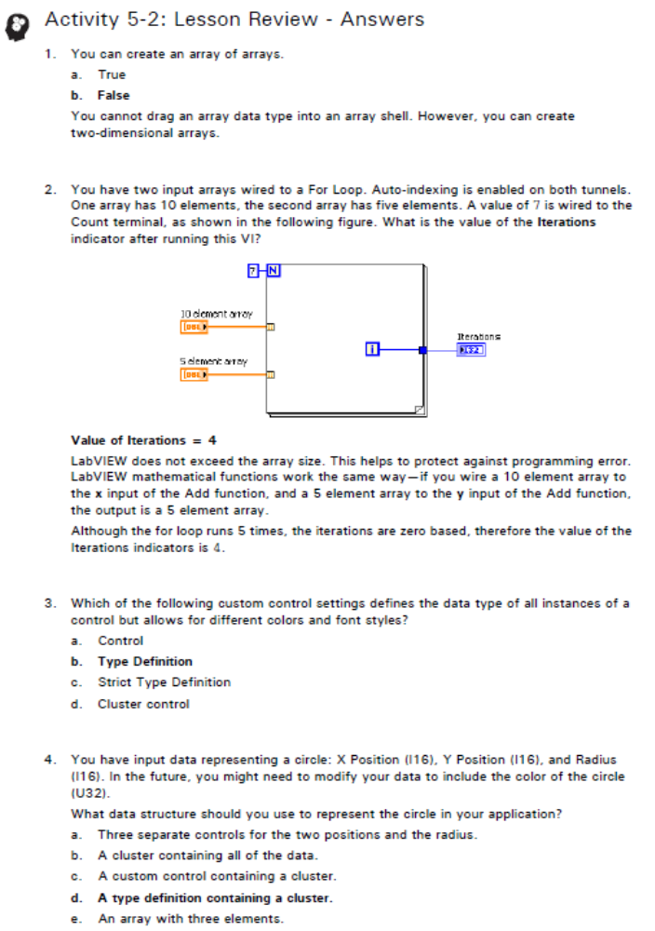

Case structures.
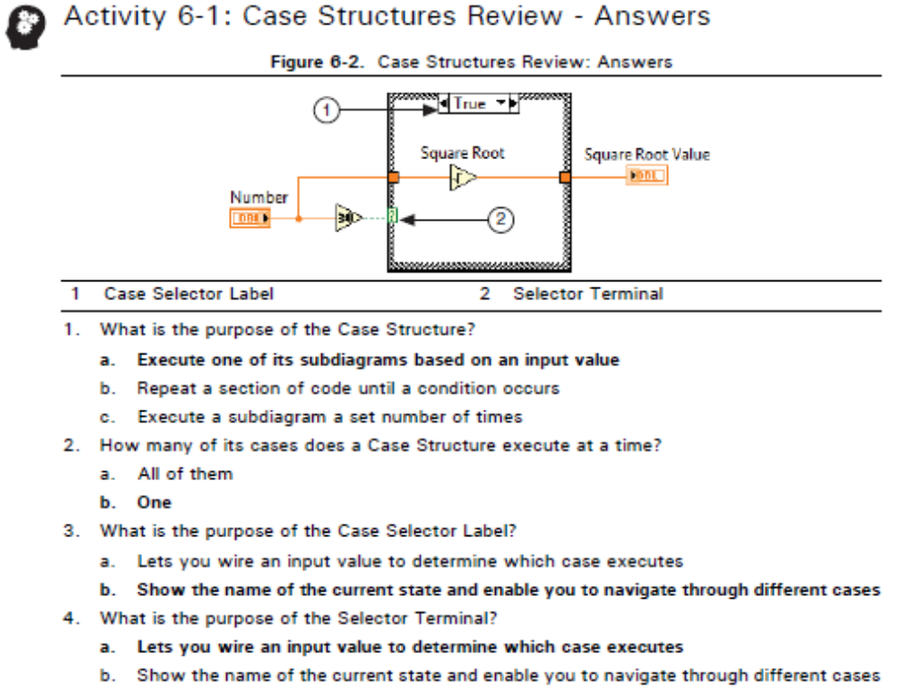

Selector terminal data types.
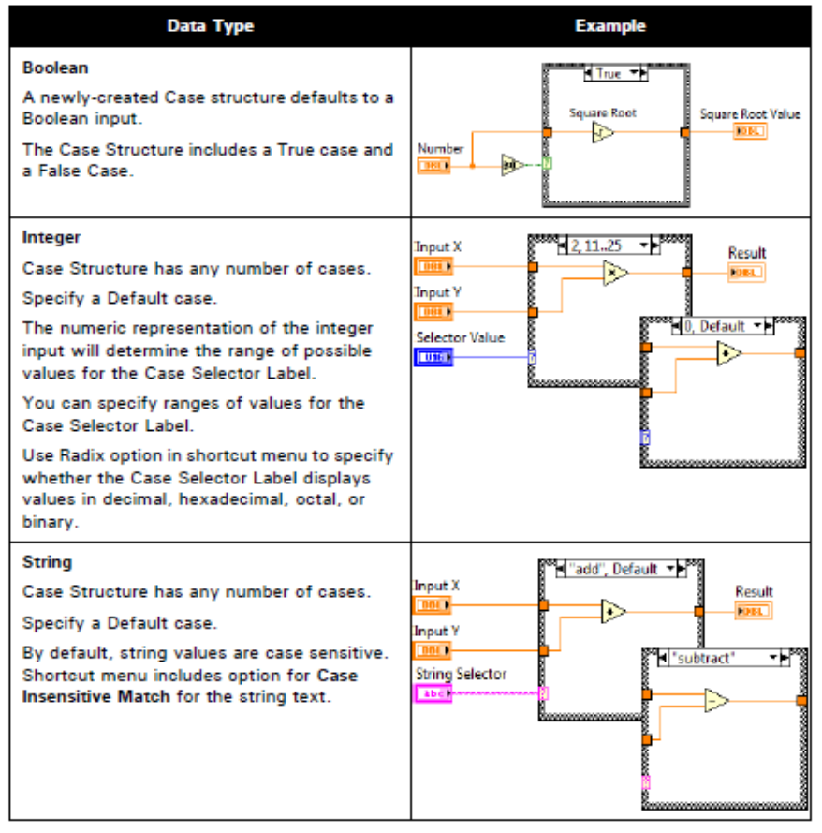
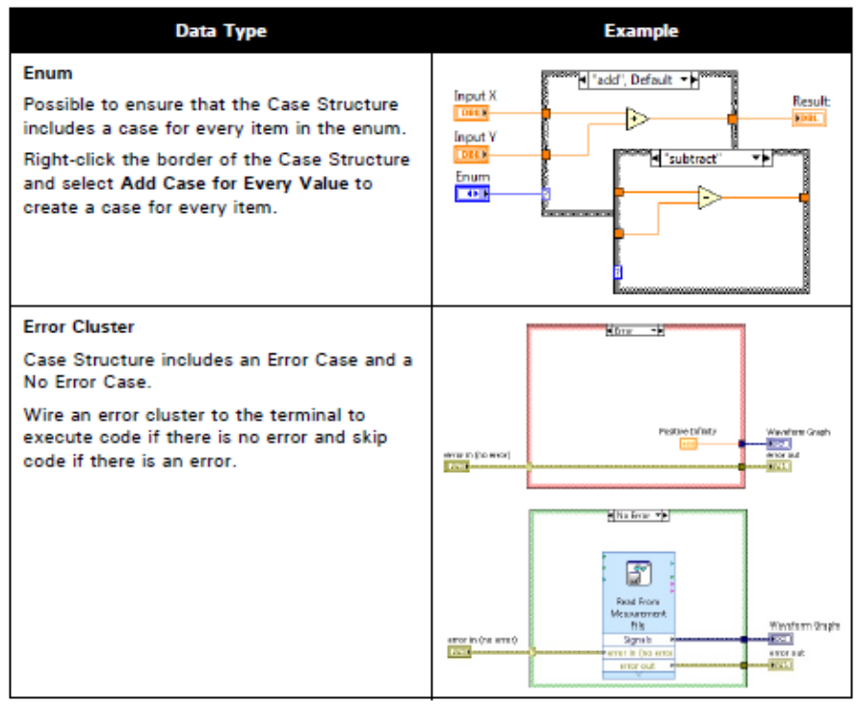
Event driven programming. Method of programming where the program waits on an event to occur before executing the code written to handle that event.

Event. An asynchronous notification that something has occurred. Events can originate from the user interface, external I/O, or other parts of the program. In this course, you will only learn about user interface events, which include mouse clicks, key presses, and value changes of a control.

Notify and filter events. LabVIEW categorizes user interface events into two different types of events:
- Notify—(Green arrow) Notify events inform you that a user action occurred. LabVIEW has already performed the default action associated with that event.
- Filter—(Red arrow) Filter events allow you to validate or change the event data before LabVIEW performs the default action associated with that event. You also can discard the event entirely to prevent the change from affecting the VI.

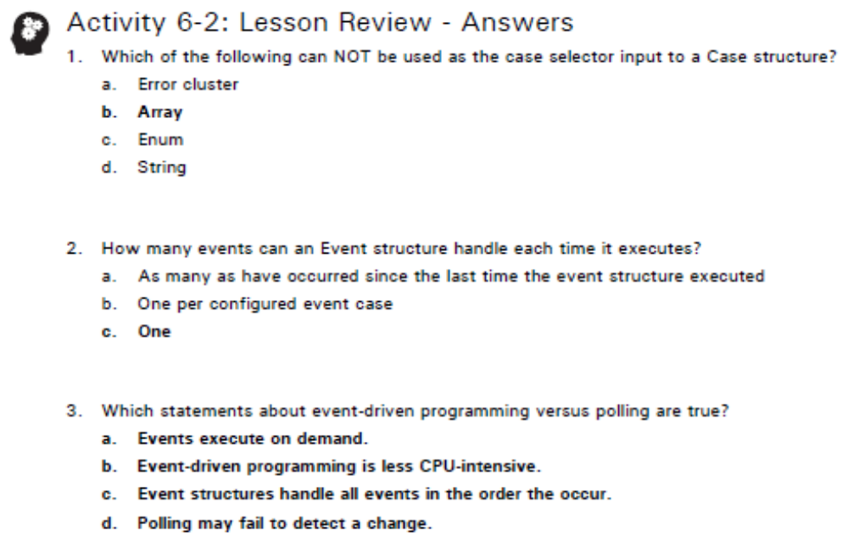

Modularity.
Modularity. The degree to which a program is composed of discrete modules such that a change tonne module has minimal impact on other modules. Modules in LabVIEW are called subVIs.
Subvi. A VI used within another VI.The degree to which a program is composed of discrete modules such that a change tonne module has minimal impact on other modules. Modules in LabVIEW are called subVIs.
Icon. A VI icon is a graphical representation of a VI. It can contain text, images, or a combination of both. If you use a VI as a subVI, the icon identifies the subVI on the block diagram of the VI.
Connector Pane. A set of terminals that correspond to the controls and indicators of that VI, similar to the parameter list of a function call in text-based programming languages. The connector pane defines the inputs and outputs you can wire to the VI so you can use it as a subVI.
Documentation. Create descriptions and tip strips for front panel objects in the properties dialog box for the object. Create descriptions for VIs on the Documentation page of the in the VI Properties dialog box.
- Descriptions appear in the Context Help window.
- Tip strips display when the cursor is over an object while the VI runs
Terminal settings. You can designate which inputs and outputs are required, recommended, and optional to prevent users from forgetting to wire subVI terminals. LabVIEW sets inputs and outputs of VIs you create to Recommended by default.
